**Young Leaders Forum  
Program Overview**

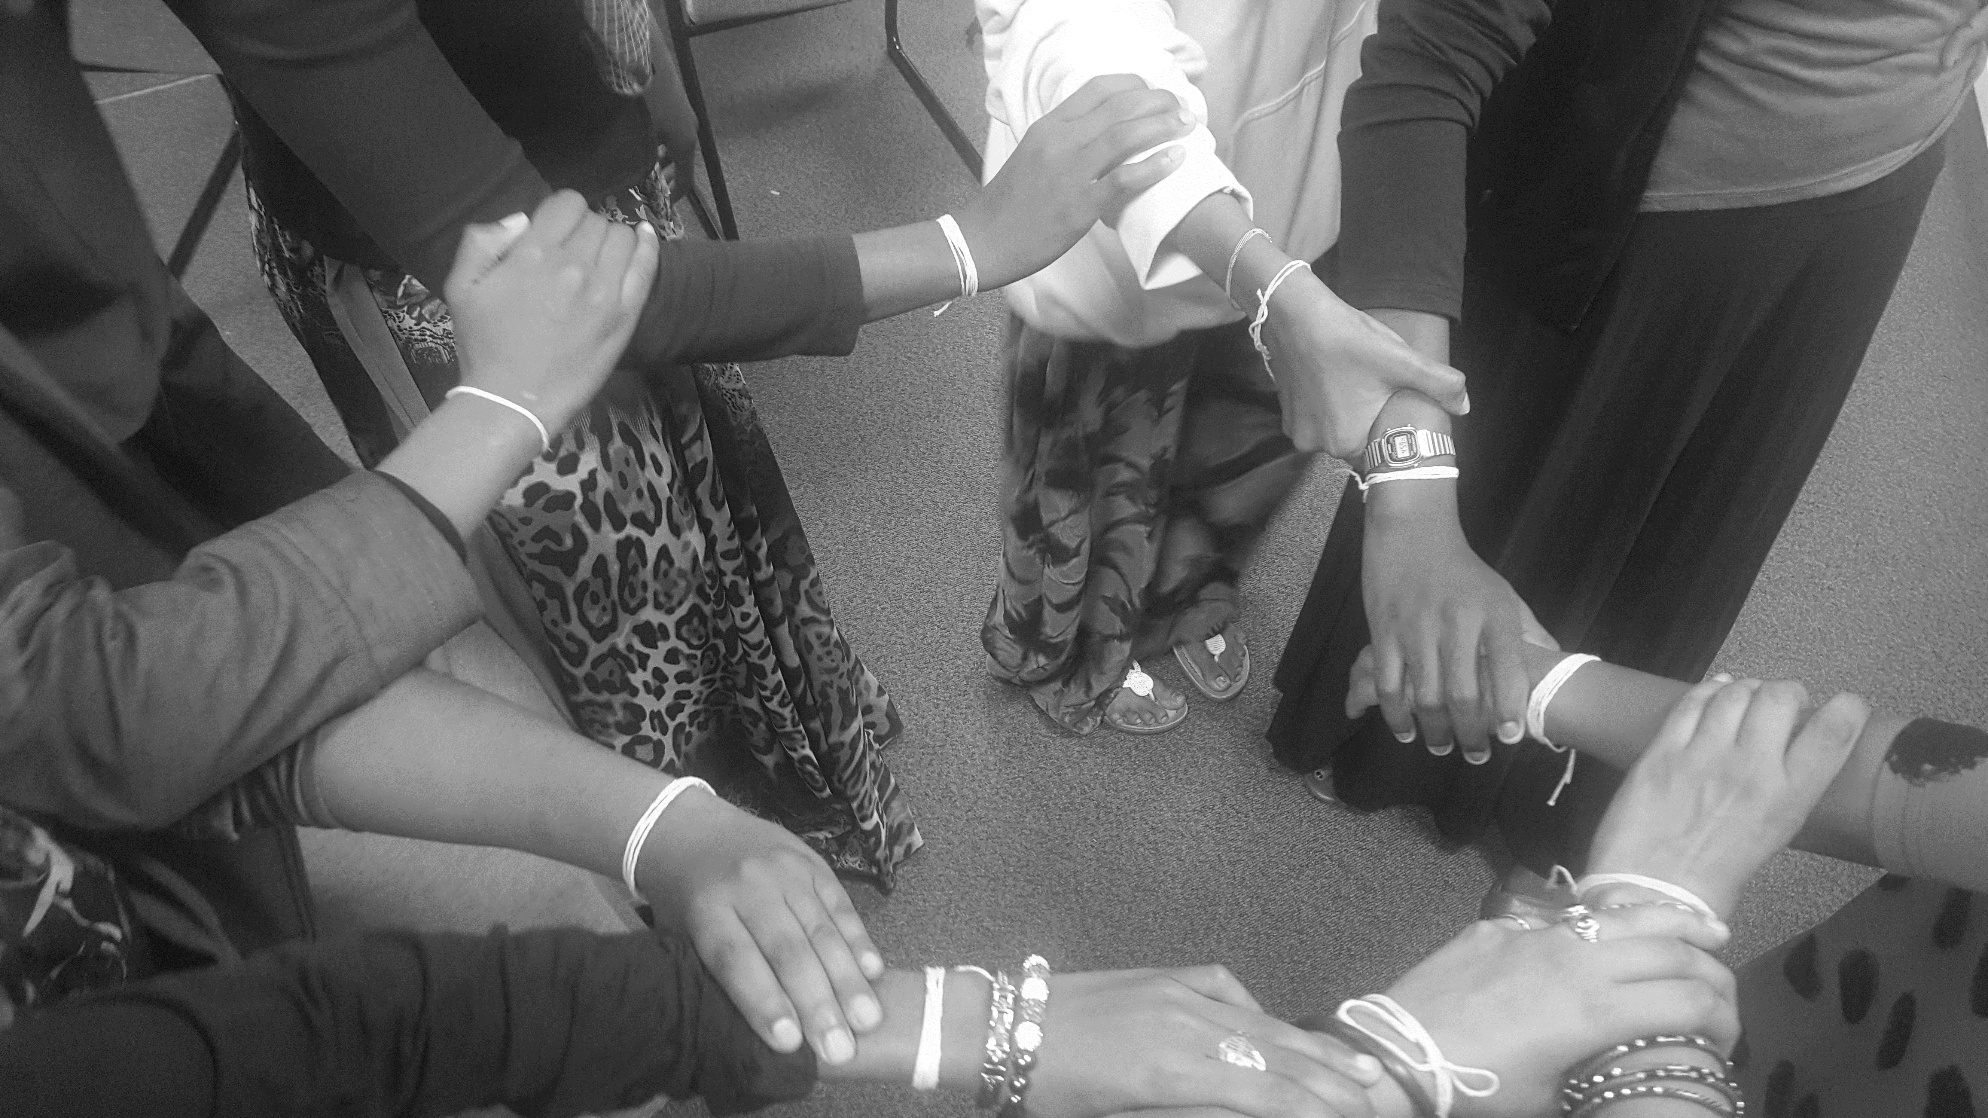

**Mission Statement***A collective of young leaders from diverse backgrounds to address community needs by intentionally fostering critical conversations and civic engagement with peers and adults in their communities.*

This year, Young Leaders Forum will focus on integration!

#### **Young Leaders Forum Timeline**

#### **Core Components of YLF**

|  |
| --- |
| **May – Application Due and Interviews Conducted**  Young Leaders Forum is looking for young adults with a passion for change and a commitment to enriching community |
| **June – Identity & Community**  We will explore the dynamics of identity, personal experiences, and community. Who makes part of our community? |
| **July – Advocacy & Equity**  What are our roles and responsibilities within change? What is the difference between equality and equity? What can advocacy look like? |
| **August – Addressing Community Need**  Respecting theme and mission of Young Leaders Forum, together we will identify and a community need |
| **September – Hosting Community Event to Address Community Need** |

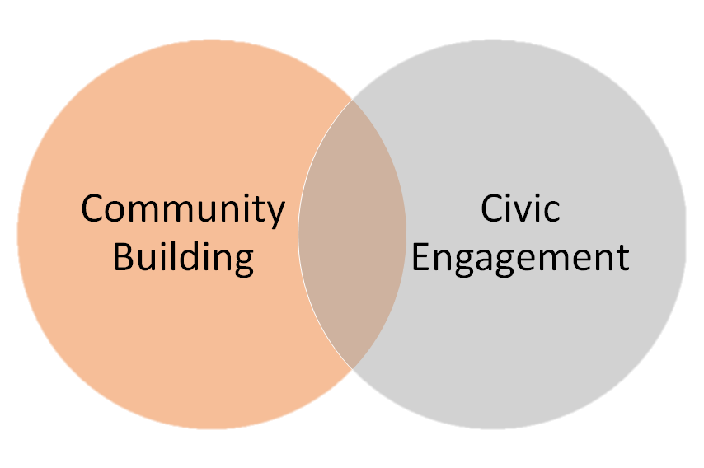

Young Leaders Forum focuses on **community building** and **civic engagement**. These core components will **strengthen** Young Leaders’ sense of **advocacy and leadership while engaging meaninfully with communities in need.**

#### **Weekly Program Schedule**

### Mondays- Enrichment 12pm-2pm Location: 1818 Gaylord St., Denver, CO

Thursdays- Field Trips/Community Engagement

*12pm-3pm: May changed depending on nature of fieldtrip

Location: Will be determined by fieldtrip. Transportation will be provided from meeting location to fieldtrip location

Young Leaders Forum is Support by:



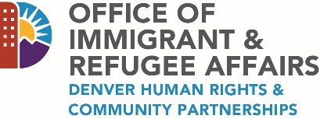

Brenda Herrera Moreno: Youth Programs Lead at the African Community Center

brenda@acc-den.org

**Q: So what is Young Leaders Forum Program?  
A:** Young Leaders Forum program is an opportunity for young adults to take a leadership role in projects that focus on addressing community needs. At the end of the program, YLF participants will host an event that addresses a community need.

**Q: How do I know if I should apply?  
A:** Anyone with the following desires:

* Excited to meet young leaders from different backgrounds and experiences
* Dedicate to developing leadership skills
* Have a desire and strong ambition to learn about their community’s needs and rights

If the above list describes you and you’re interested in learning more about the program then **please apply** by filling attached application!

**Q: What happens after I apply?  
A:** Applications are due **Monday May 15th** . Staff will follow up to confirm your interview spot.

**Q: How old do you have to be to apply?  
A:** Young leaders should be between the ages of 16-20. Everyone in this age range is encouraged to apply!

**Q: When does the program start/end?  
A:** Monday June 5th, is the first day! The program ends September 15th, 2017

**Q: Does it cost money to be in the program?  
A:** Program is free!

**Q: What if I have a job or may be a part of something else this summer?  
A:** Please let Brenda Herrera Moreno know as soon as possible. We know there are other activities or responsibilities that you may have. It is important to communicate with us any information that might affect your participation in Young Leaders Forum.

**Q: What is the adult recommendation letter? Why is it necessary?**

**A:** The adult recommendation letter can be written by any adult around you. It does not have to be very long but should represent how they see you. We use the recommendation to invite another perspective to our application process.

**Q: What if I have more questions?**

**Young Leaders Forum  
Frequently Asked Questions**